Wildlife Strike Final Project Report
Name | Rabin Acharya | Week and Date | Week 7 October 11 2026

Recommendation
Pilot logistic rankings for 11 monthly wildlife-management reviews across 53 selected airports while retaining routine prevention and checking report availability.

Question and stakeholder
Airport wildlife-management teams need to prioritize additional review while retaining routine prevention. This project predicts whether a selected airport will report at least one damaging strike in the next calendar month. It evaluates retrospective prioritization, not individual-flight risk or intervention effectiveness.

Data and audit
The workbook contains 353,804 strike reports spanning 1990 through August 2026. Removing eight repeated incident identifiers leaves 353,796 reports. All dates and binary damage values are usable. The wildlife-size comparison retains 312,726 reports and excludes 41,070. Forecasting uses only 2012–2024, with 2012 providing the initial history. The resulting modeling panel contains 7,632 airport-months across 53 airports. Full audit details and the source checksum are saved in results/audit.json.

Descriptive findings
The all-file size comparison reproduces the earlier descriptive purpose. It is distinct from the 2012–2024 forecasting sample. Missing size or invalid damage categories are excluded, and Wilson 95% confidence intervals are calculated. The earlier reports contain a one-row source-count discrepancy. Actual workbook counts supersede those statements.
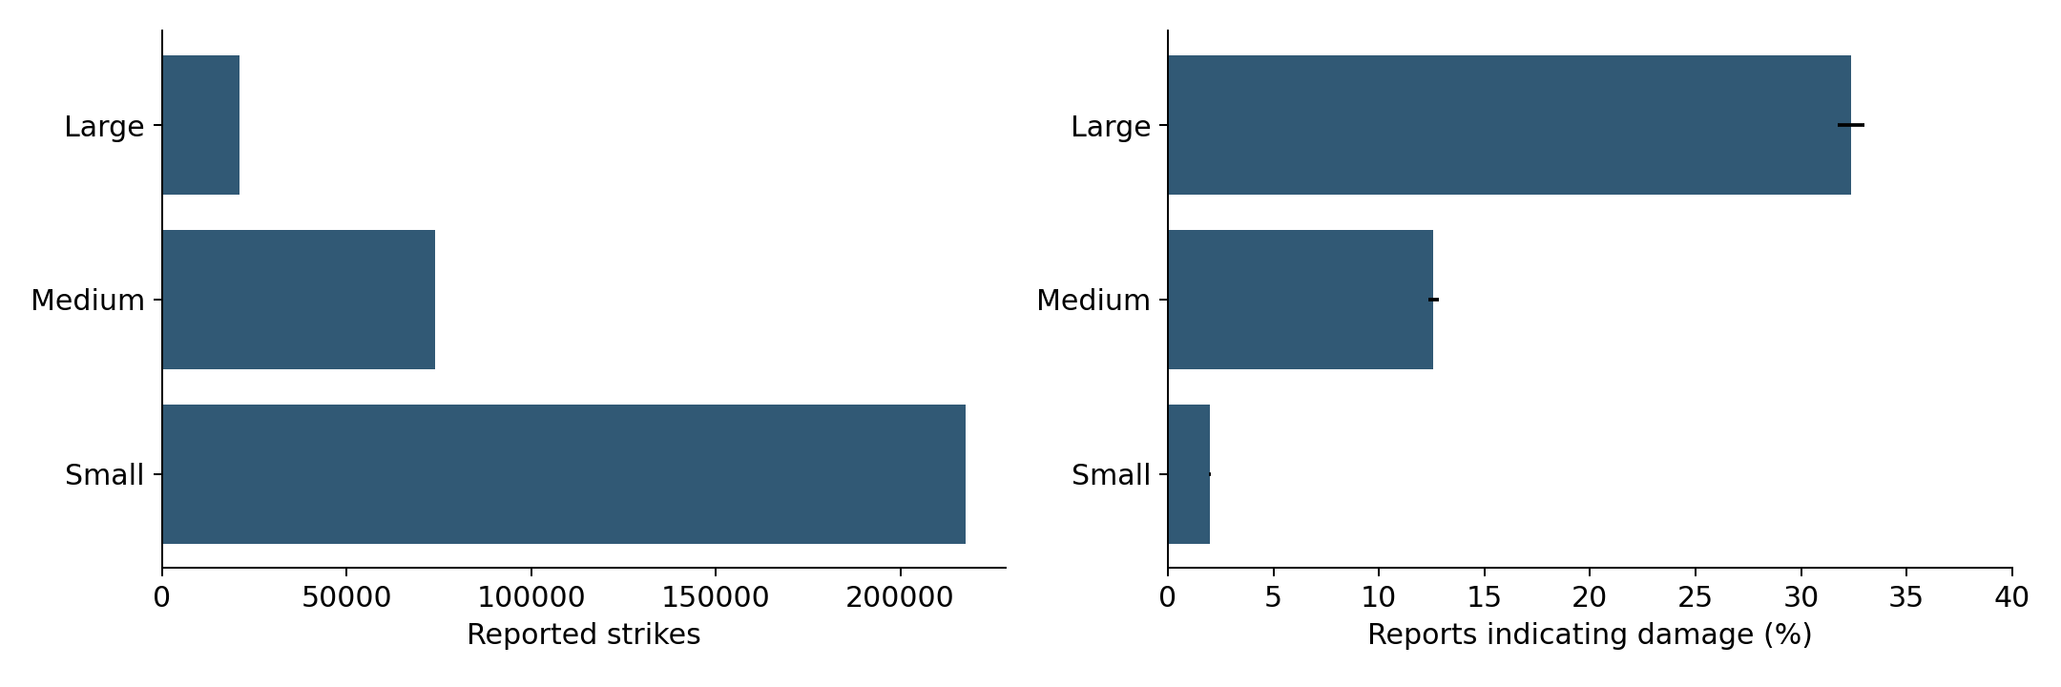

Design and reproducibility
Select airports using 2012–2022 only: at least 119 reporting months and at least 12 damaging months. Exclude ZZZZ and invalid identifiers. Create every airport-month including months without a damaging report. Shift one-, three-, and twelve-month strike and damage counts by one month. Add month sine/cosine and airport identity. Drop the first twelve months as the history warm-up. Tune logistic C and forest minimum leaf size using mean average precision over yearly 2020–2022 folds. Fit both models through 2022 without refitting on 2023. Evaluate 2023 and 2024. Rank separately each month, break ties by airport identifier, and review ceil(0.2 times airport count). Save all predictions, models, coefficients, and diagnostics.

Final test results
All methods use 636 test observations and 186 damaging months. The selected model under the earlier switch rule is logistic.
2024 method | Captured | Missed | Precision | Brier
logistic | 69 | 117 | 52.3% | 0.191
forest | 67 | 119 | 50.8% | 0.185
airport_history | 61 | 125 | 46.2% | 0.194
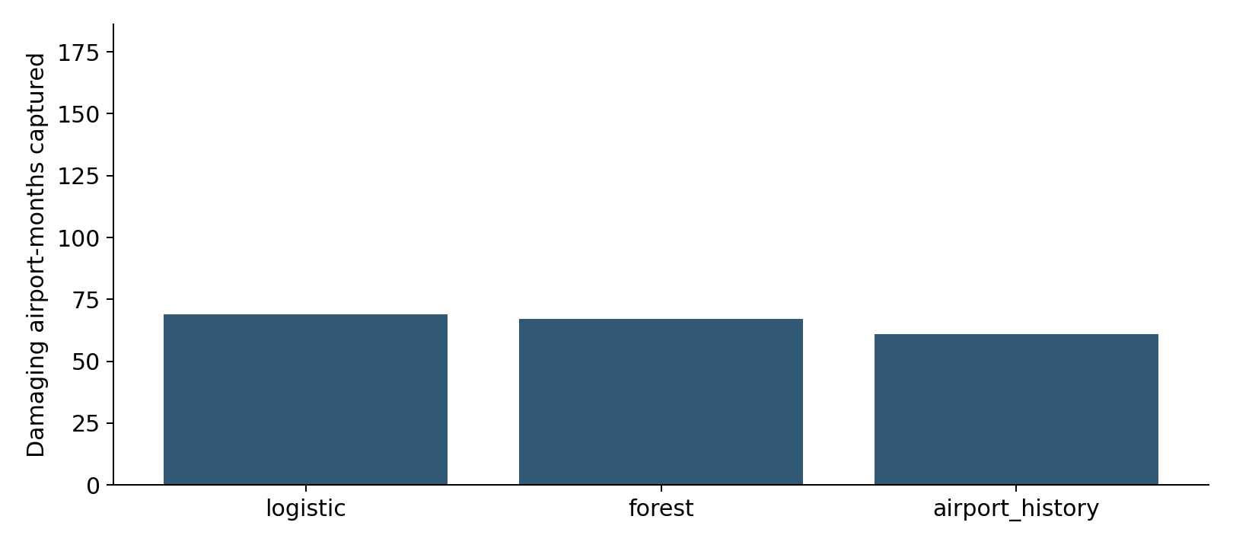

Probability calibration
Calibration is checked visually using quantile bins and by Brier score. No calibration transformation is fitted to the test year. The baseline assigns each airport its training-period damaging-month fraction. A constant prevalence baseline provides a probability reference.
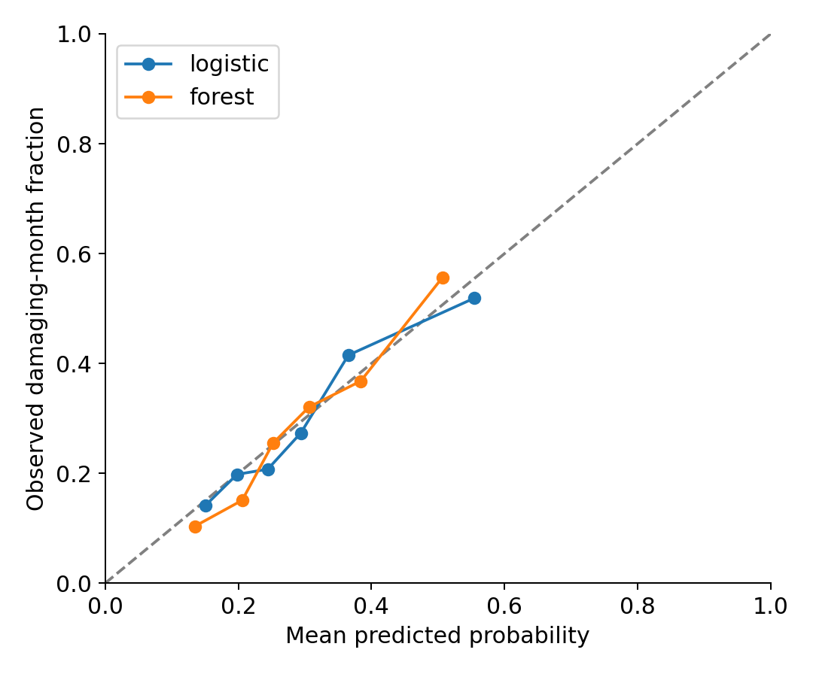

Interpretation and limits
The chosen ranking captures 69 events and misses 117. Its baseline comparison is more informative than a model-only score. AP and AUC describe discrimination, while Brier describes mean squared probability error. No uncertainty-adjusted superiority claim is made. The holdout switch rule selects a model using test outcomes, so the final selected model needs fresh prospective evaluation. Reporting timing, selection, absent exposure, and changing practices limit transportability. The annual dataset extends beyond the forecasting period; future periods are excluded. A retrospective lag does not prove real-time availability.

Next decision
Audit report availability and run a prospective monitored comparison with the historical airport list. Log review workload and actionable findings. Measure missed damaging reports and consider intervention impact separately. Do not reduce routine prevention on the basis of the ranking.

Reproduction
Reproduce the analysis using README.md and code/run_analysis.py in the project package. Results and final settings are saved there.

